Grade 4
TetroMillionaire

Description: | Students will:  Paint a Tetromino shape and script it to move on the y axis.  Write conditional statements to change the location of the Tetromino.  Use a random number generator tile and x/y coordinates.  Make sibling copies of the Tetromino and repaint the copies to make the whole set of Tetrominoes.  Paint a tromino script it. Make sibling copies  Paint a pentomino and script it. Make sibling copies  Paint a scoop or net and script it to move with keyboard input.  Create a variable called: Score.  Write conditional statements controlling score’s increase and decrease.  Create a reset script and make a button to fire the script.
Project View | 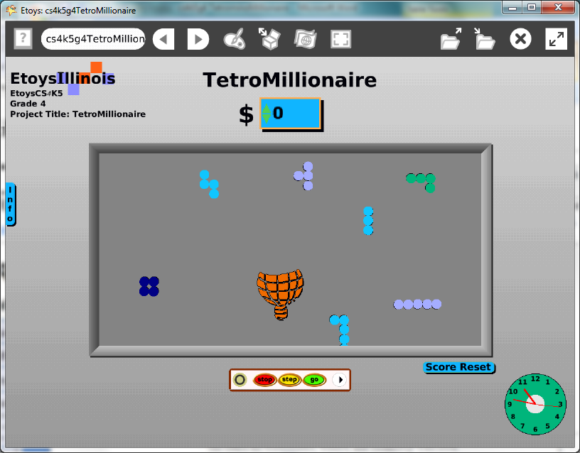
Subject: | Math, Art
Etoys Quick Guides | Click the question mark in Etoys to open the set of interactive tutorials for basic tools and techniques.
Vocabulary: | Tetromino, polyomino, tromino, pentomino, random, variable, increase by, decrease by, X and Y coordinate points on a plane, <, >, thousand, hundred thousand, million, ten million, hundred million
Lesson 1:  Paint Tools: Brushes  Script Tiles: X and Y Tiles  Script Tiles: Test  Script Tiles: Random Numbers  Script Tiles: Heading  Navigator Bar: Keep Find Projects | This project will take several class periods. Give students time to experiment with the ideas and to plan a course of action. Ideas and plans take time and thought to develop and can not be rushed.  Paint a Tetromino. Write a script for it. It is good practice to name objects and scripts as they are made.  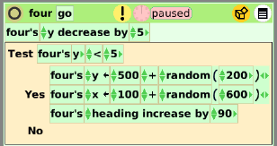  Give students time to experiment with different values in these commands so that their object moves exactly the way they want it to move. This object will be copied with a special copy feature that gives all of the copies the same scripts and a change in one script will change the scripts of all of the siblings.  Hold down shift as you make copies to make them sibling copies.  Make sibling copies and use the repaint tool to modify the shape to make all the possible Tetromino.  Publish: nameMillion; for example KateMillion
Lesson 2:  Script Tiles: World Input | Paint another shape with five parts and script it.  Paint another shape with three parts and script it.  Make sibling copies of these two shapes and repaint in different shapes with the same number of parts.  Paint a scoop, bar, basket, or racquet to use to touch the polyominoes during the game.  Open a Viewer for the scoop and make a Script to move the bar left and right using keyboard input.  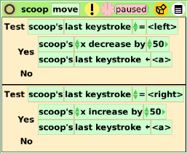  Give students time to experiment with the scoop’s motion for each arrow click. Discuss.  Keep the project.
Lesson 3:  Menus: Viewer Icon Set  Menus: Watchers | Create a variable for the scoop and name it: score.  Use the new variable in a script to increase and decrease depending on what kind of polymino the scoop touches.  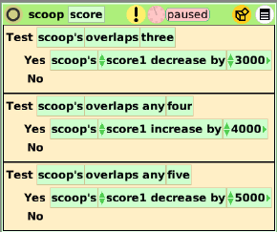  The example game increases the score for catching tetromino and decreases the score if a pentomino is caught. Give students time to experiment with different combinations and ratios of increases and decreases. Discuss ideas.  Use a simple or detailed watcher to show the score.  Keep the project
Lesson 4:  Supplies: Playfield  Menus: Button Fires a Script | Put the game pieces on a playfield and use the fill and border tiles to change the color.  Type or draw a title for the project.  Type the rule for the game or other information about how to use the keyboard arrows.  Make a flap and put the rules in the flap. Use the flap’s white menu to: change the label, location, and colors.  Add a clock to the project and use a grab patch tool to capture the start time and ending time. See how long it takes to make a million, ten million, etc.  Make a reset script to make the score go back to zero. Make a button to fire the script.  Give students time to try projects made by others in the class and to modify their project after that experience.  Keep the project.
Lesson 5 | Challenge students to make a new game in one class period using pieces from this game.
Standards: | Common Core Standards  Mathematics: 4.NBT.2.4; 4.G.2.3  Bloom’s Taxonomy/Cognitive Domain:  Knowledge: knows, selects, lists  Comprehension: rewords  Application: produces, constructs, changes  Analysis: analyzes, compares, experiments  Synthesis: categorizes, creates, modifies, plans  Evaluation: compares, assesses  NETS  1. a, b  4. a, b, c, d
Resources: | Etoys Help Quick Guides: always available in Etoys. Open Etoys and click the question mark to open a set of interactive tutorials of basic tools and techniques.  www.etoysillinois.org projects, lesson plans, software download  www.mste.Illinois.org more math, science, and technology resources  www.corestandards.org Common Core Standards  www.squeakland.org software and Etoys projects  www.nctm.org Standards and Focal Points for each grade level
kh January 2011

